The class diagram consists six classes which consisting of User class, Parent class, Child class, Location class, Notification class and Geo-fence class is shown in Figure 4.1. The User class will be inherited by Parent class and Child class as they both are the user using the device. The Parent class and Child class will both using Location class in which Parent depends on the Location class to get the location history of their child and the Child class is using the Location class to record their current location. Besides, the Parent class will also use the Geo-fence class to set the Geo-fence to monitor the child and the Geo-fence class is then passing the Geo-fence information set by the parent to the Child app by using the Child class to add that information into Geo-fence API called from the Child app. The Parent class and child class will both using notification class as child will send notifications to parent and on the other hand parent will receive notifications from the particular child.

.

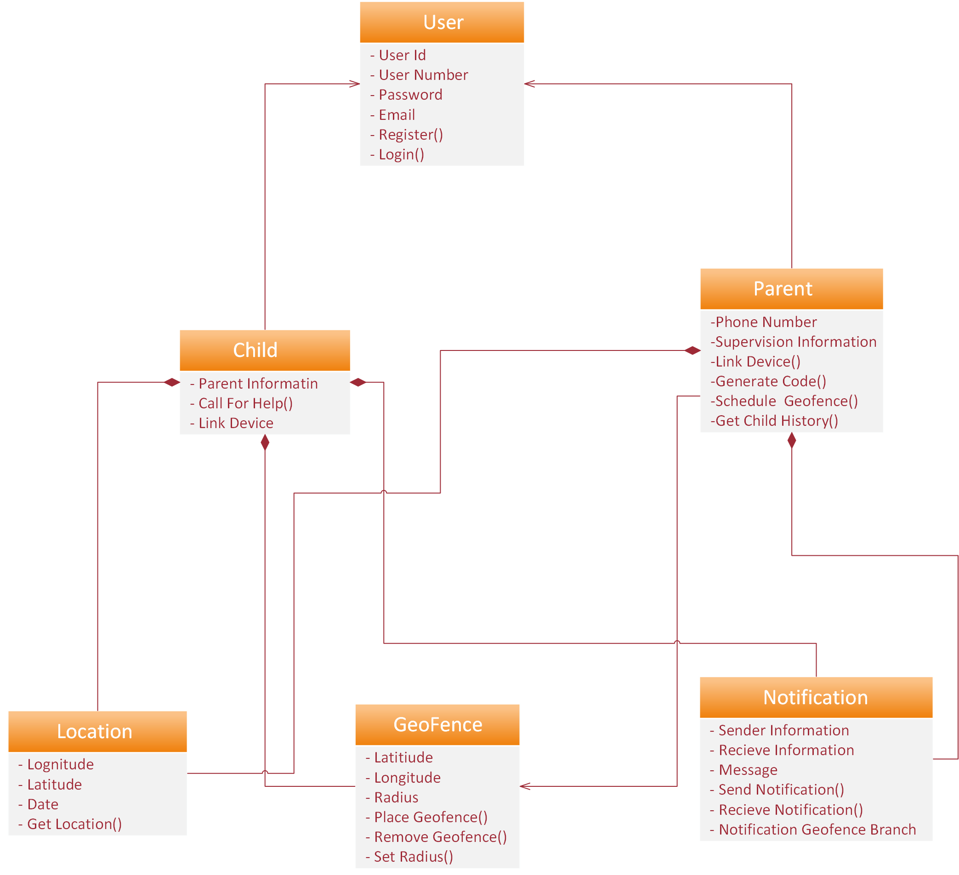

The ERD diagram that consist of 5 tables, which is Parent, Child, Location Coordinates, Notifications and Geo fence table is shown in Figure. The relationship between parent object and child object is One to Many relationship as the parent can have more than one child.

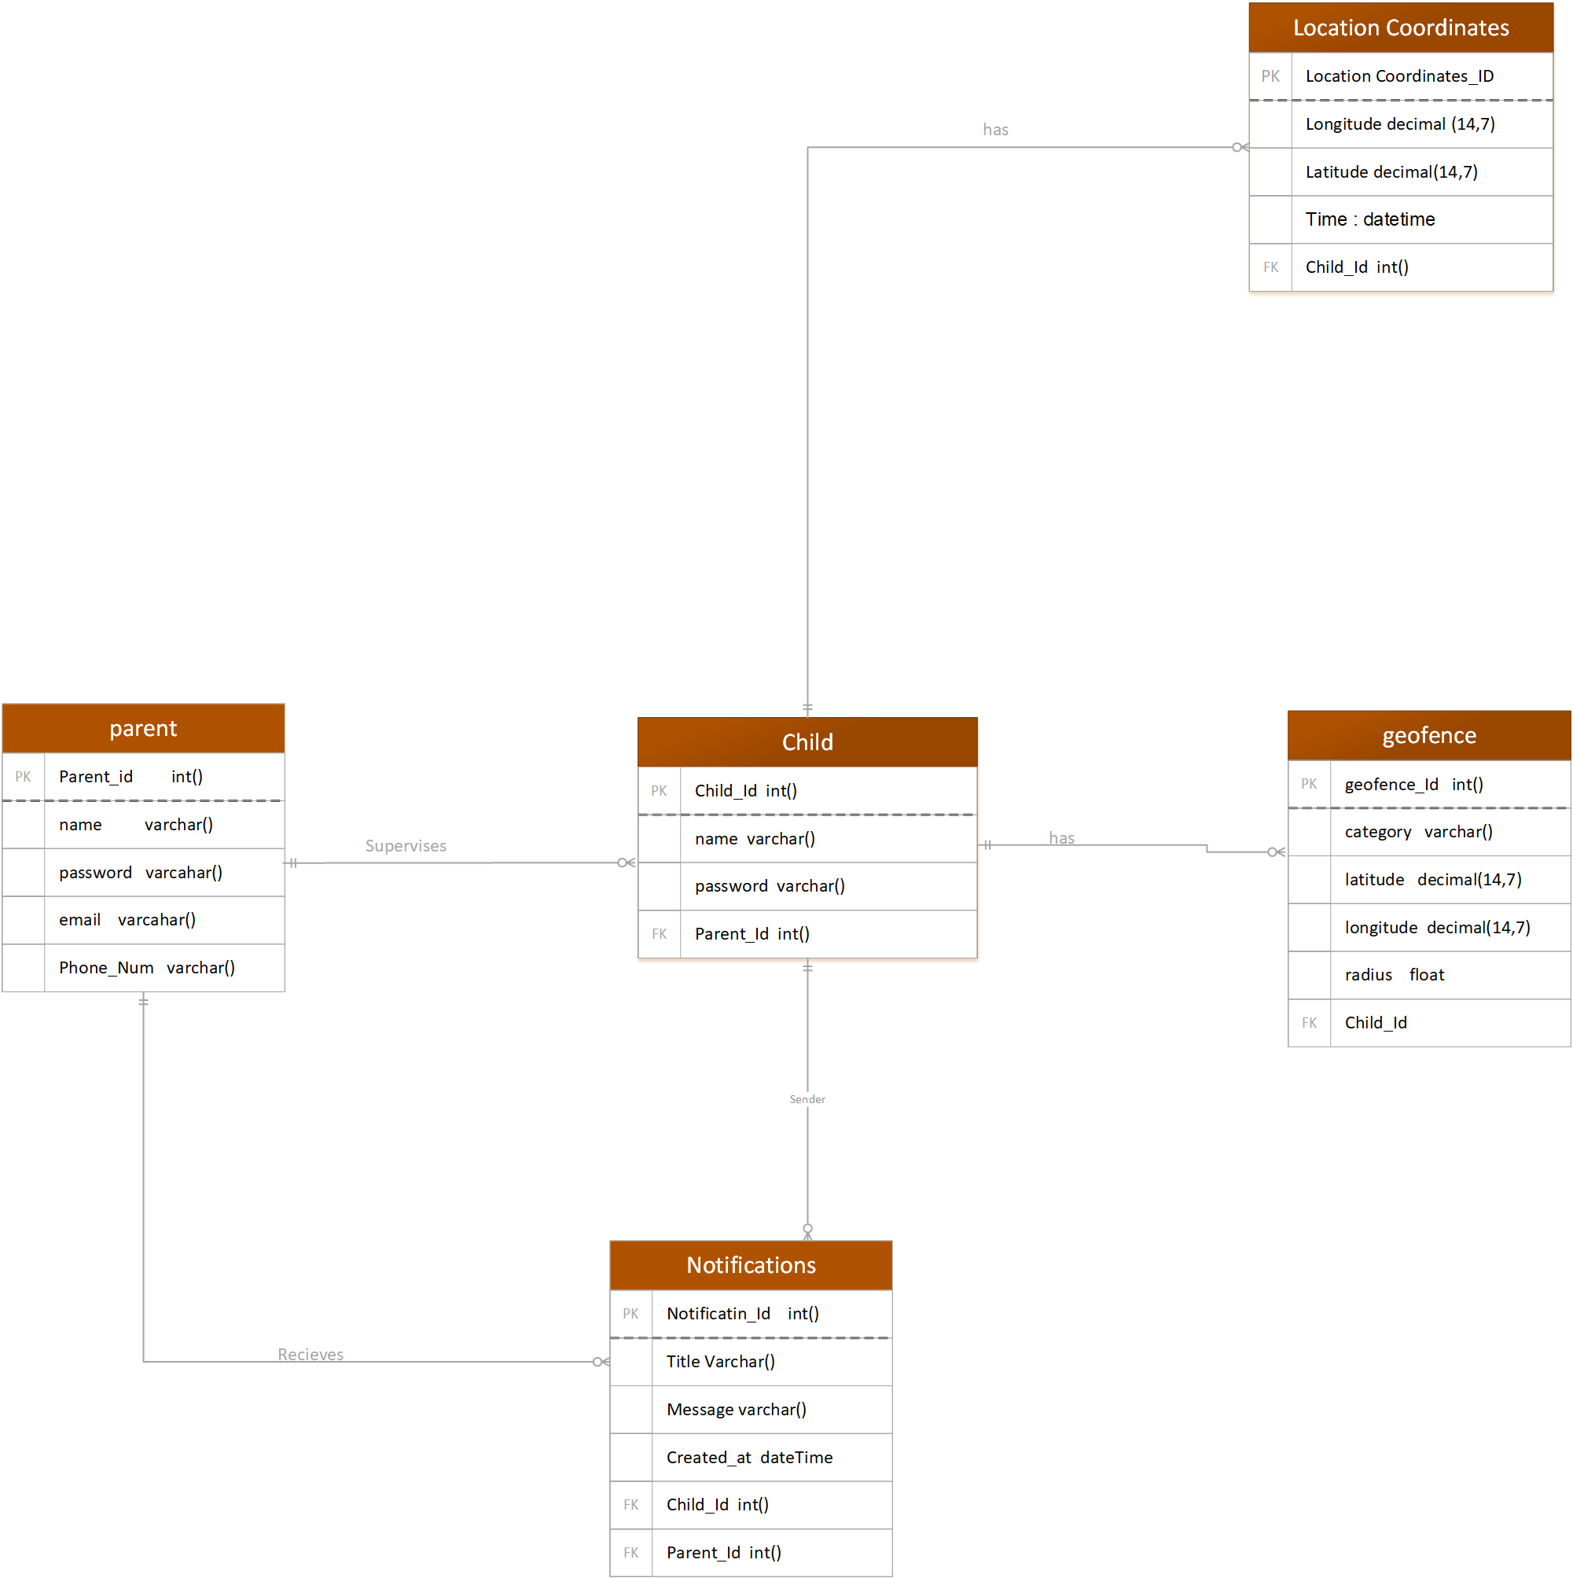

Activity diagrams are intended to model both computational and organizational processes. Activity diagrams show the overall flow of control. In this system, activity diagram is used to show the flow of activities for both users and administrators as shown in Figure. These activities include sign up and login, which allow them to perform other activities according to their role.

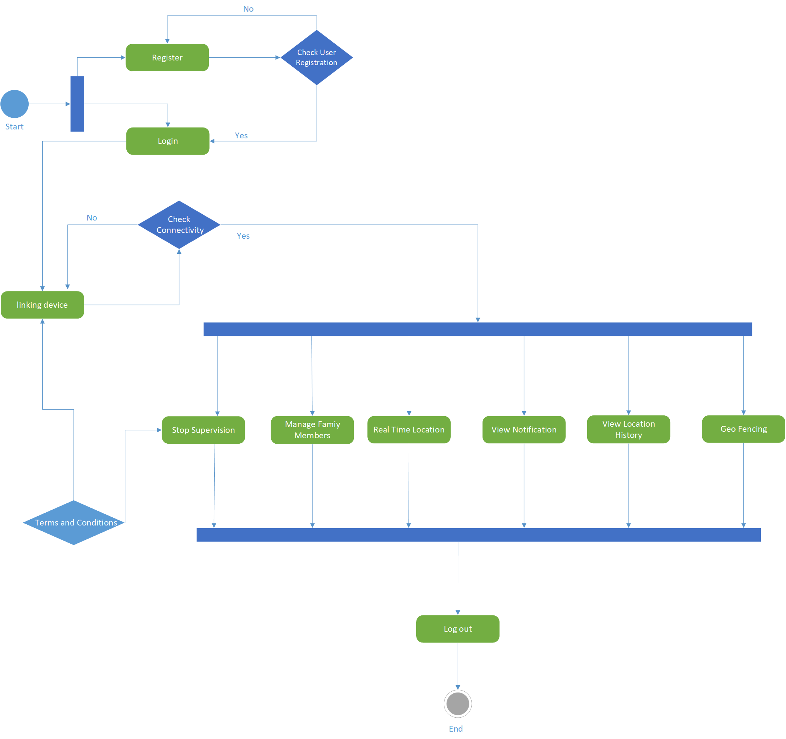

Component diagrams are used to model physical aspects of a system. Component diagrams are used to visualize the organization and relationships among components in a system. These diagrams are also used to make executable systems.

